Biochemistry Answers

Name
Institution of Affiliation
Date

Biochemistry Answers
1.
a.
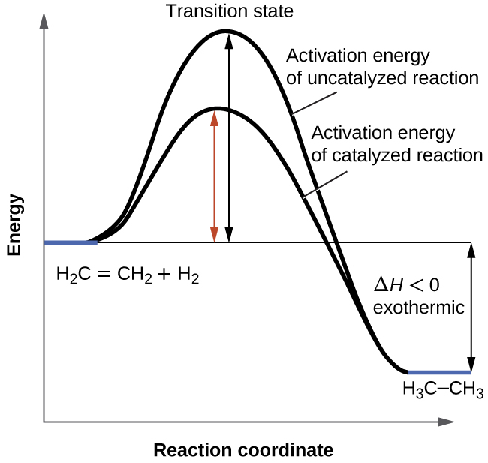
The enzyme helps provide an alternate mechanism reaction with lower energy of activation for both forward and backward and reverse reactions.
b.
k = Ae^{-E}_{a}^{/RT}
K_{cat} = Ae^{-E}_{a, cat /}^{RT}
K cat/ k = e ^{−Ea,cat/RT}/ e^{−Ea/RT}
= e− $\frac{ Ea,cat-EaRT}{RT}$ T = 310K
From the above equation we can related that the catalyzed reaction is ten times faster than the uncatalyzed reaction, given the ΔG ‡ (catalyzed) = 450 kJ/mol and ΔG ‡ (uncatalyzed) = 500 kJ/mol. The uncatalyzed reaction uses a lot of energy compare to the catalyzed reaction.

2.
a.
2.5/ 1+2.5 =0.7142
b.
1/[S] | 1/[Vo]
1.000 1/ mM | 0.0833 (mL•s)/μmole
0.500 1/mM | 0.0500 (mL•s)/μmole
0.250 1/mM | 0.0345 (mL•s)/μmole
0.125 1/mM | 0.0286 (mL•s)/μmole
0.0831 1/ mM | 0.0250 (mL•s)/μmole

V_{max}= 1/Vmax = 1/0.0196 = 51.02
Km/Vmax = slope =0.0631 =Km/51.02
=51.02*0.0631
= 3.219
3.
a.
The catalytic triad provides a paradigm for the structural and chemical features of enzymes that allow them to facilitate a difficult reaction. The structures of trypsinogen proteases reveal that the active sites of these enzymes shared a particular stereochemical arrangement of residues crucial to their activity.
Ile 16 is reacting with the Asp194 after cleavage of propeptide, hydrophobic interactions of the Ile 16 side chain of trypsin. Proenzymes are produced in inactive way, that they are not functional until biochemical functions occur. The zymogen active site is revealed when hydrolysis occurs
b.
Trypsin being a serine protease, mostly active in pH ranges of 7 and 9, and a temperature of 37⁰C. from the above graph as the pH during the catalysis increases so do the increase in the Kcaf till a point of maximum pH where the trypsin enzyme is highly active. An increase in pH leads to the condition environment of the enzyme unfavorable leading to the decrease in Kcaf until fully denatured. The enzyme trypsin employs a powerful attack of the nucleophile carboxyl group of the substrate.
c.
The reaction should be, monitored at close ranges making sure that the pH at which trypsin enzyme works best is maintained at close ranges. Trypsin being a serine protease, mostly active in pH ranges of 7 and 9, and a temperature of 37⁰C. from the above graph as the pH during the catalysis increases so do the increase in the Kcaf till a point of maximum pH where the trypsin enzyme is highly active. An increase in pH and ionic state leads affecting the strength of the enzyme.
d.
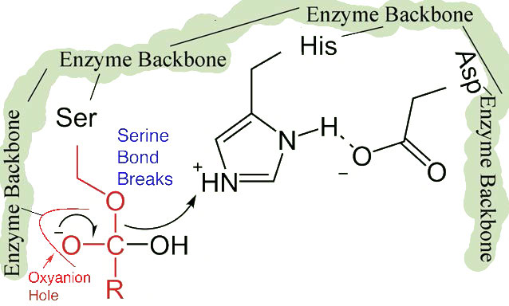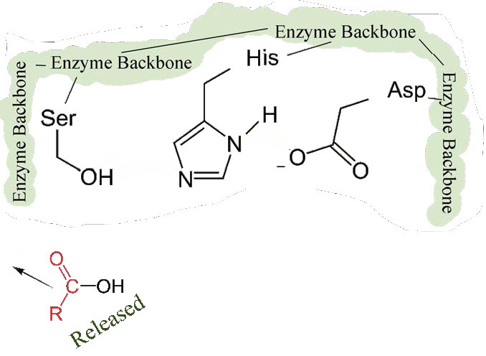

4.
- random displacement mechanism
- ping pong displacement mechanism
- single displacement mechanism
. lactate dehydrogenase binds it substrate through formation of LDH/NADH, a complex substrate, this enzyme catalyzes the reaction on the conversion of pyruvate and lactate with a factor present; nicotinamide adenine dinucleotide. The are many residues in the active site of NAD and LAC; Cys – 149, His – 176, Ser-177. the mechanism of NAD and LAC can be determined, since they are enzymes, their function is specific to their structural. This is because they bind with appropriate substrate only when the alignment that is correct and also the orientation of the molecule. They depend on orientation and alignment of the active site which is a geometrical model called the lock and key model.
1.

a.
Curve a is no inhibitor. The Vmax is maximum due to the high activity of the enzyme on the substrate.
b.
Curve b is a competitive inhibitor. Competitive inhibitor of an enzyme is a molecule that the structure resembles the normal substrate and is able to bind to the active site and hence stop enzyme functioning. The Vmax does not change, since an increase in the amount of substrate can lead to swamping of the inhibitor, this helps the enzyme to effectively not recognize the inhibitor during high concentration. The Km of competitive inhibitor rises up due to the more substrate it takes to get reaction to Vmax/2 due to completely inhibition
c.
Curve c is a non-competitive inhibitor, these molecules never bind for the active site in the enzymes since they have no resemblance with the substrate. Presence of a non- competitive inhibitor Vmax decreases. The Km does not change, due to Km being the affinity measure of an enzyme to its substrate. The non-competitive inhibitor does not affect Km, therefore unchanged
2.

a.
Michaelis-Menten kinetics describe the enzymatic reaction rates through a relation of reacting v (product rate formation [P]), to [S], the substrate concentration S
$$V=\frac{d[P]}{dt}= \frac{Vmax [S]}{Km+[S]}$$
The maximum rate archived by the system is the V_{max}, occurring during saturating substrate concentration. The Michaelis constant K_{M} which represents a numeric equal to the substrate concentration at which rate of reaction is half of V_{max}
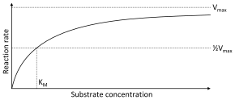
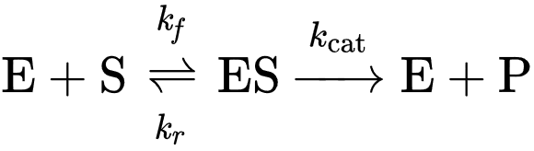 where K_{f} the forward constant rate, K_{r} the reverse constant rate and K_{caf} catalytic constant rate. This is a reversible enzyme substrate binding process
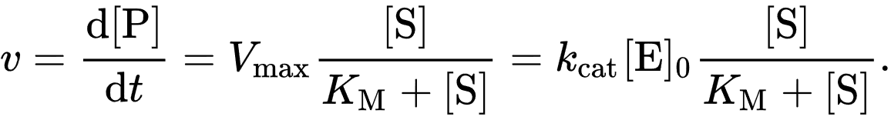
b.
Determine V_{max} and K_{m} for aconitase
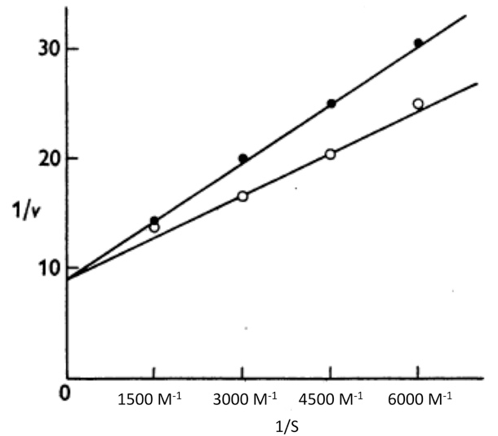
From the graph slope of with presence inhibitor
Slope = $\frac{25-20}{4500-300}$ = $\frac{1}{300}$
Find the equation of line from the coordinates (3000, 20) (4500, 25)
y - y1= m (x – x1)
y – 20 = $\frac{1}{300} (x-3000)$ = y =$\frac{1}{300}x+10$
equation for with absence = y =$\frac{1}{300}x+10$
given that $\frac{1}{Vo}= \frac{Km}{Vmax [S]}+ \frac{1}{Vmax}$
Vmax = 1/ 10 = 0.1
Km/Vmax = slope = 0.00333
Km = 0.0003
For that without inhibitor
Slope = $\frac{25-20}{4500-300}$ = $\frac{1}{300}$
Find the equation of line from the coordinates (3000, 15) (4500, 20)
y - y1= m (x – x1)
y – 15 = $\frac{1}{300} (x-3000)$ = y =$\frac{1}{300}x+10$
equation for with absence = y =$\frac{1}{300}x+5$
given that $\frac{1}{Vo}= \frac{Km}{Vmax [S]}+ \frac{1}{Vmax}$
Vmax = 1/ 5= 0.2
Km/Vmax = slope = 0.00333*0.2
Km = 0.00067
c.
Fluoroacetic acid enters Krebs cycle and is converted to fluorocitrate. This compound competitively inhibits aconitase preventing isocitrate conversion from citrate

d.
The Kcat/Km values show the second order rate of reaction of E and S = M⁻¹S⁻¹. It is used to compare the efficiency of two enzymes that are catalyzing the same reaction. It is a measure efficiency which helps to determine whether the rate is limited by the product creation or the environment substrate amount. The substrate that has the highest value gives the best enzyme substrate. Enzymes with high K_{cat}/K_{M} ratios have attained kinetic perfection since they are very close to reaching complete efficiency, this is only limited by the rate at substrate encounter in solution. Therefore, citrate synthase is more effective than acetyl CoA

3.
a.
.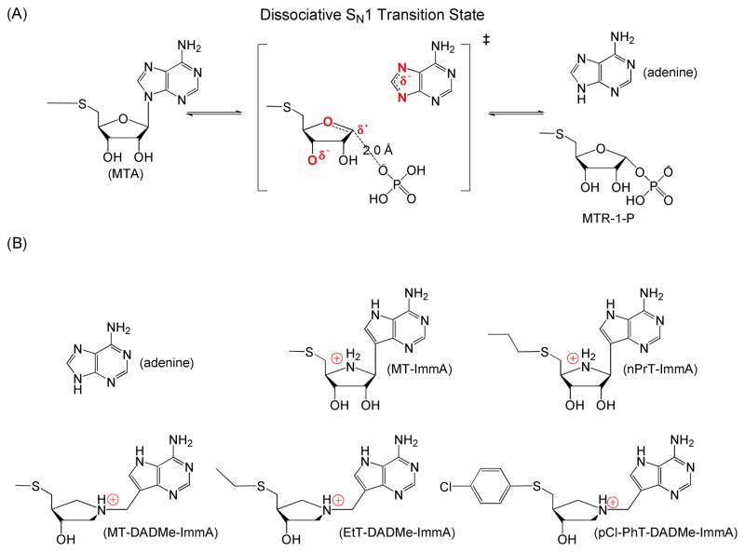
MT-DADMe-ImmA being a second generation inhibitor mimics MTAP fully dissociative transition state by distance increase between the pyrrolidine group and deazaadenine through a methyl group, it induces apoptosis in neck cell lines carcinoma and in two head neck, leading to prevention of FaDu tumors from growing, also leads to inhibition of metastases and tumor growth in the human lung cancer.
b.
Enzyme activity gives the measure the quantity of enzyme present in a reaction. Two ways can be used to measure enzyme activity: by substrate disappearance monitoring or the product appearance. Product appearance measurements is accurate because of small changes are detected [P] (when [P]=0), hence [S] significant changes can be detected
c. Is DADMe-ImmA is a better inhibitor in Ts geometry than immA and hence thermodynamically favored. The binding of MTAP/phosphate complex by TS analogues reaction is fully entropic, which is different to TS analogue binding to a related human phosphate complex, it is fully enthalpic
c.
There have been many tests done on the MTA analogue as inhibitors of thermophilic enzyme, 5’-methylthiotubercidin inhibition indicates that the purine ring N-7 is not involved at all in recognition process. Use of imidazole from the base of purine leads to complete loss of inhibition activity. The protonation is only allowed during a physiological pH leading to enzyme binding prevention.
Inhibitors of MTAP increases MTA intracellular causing feedback inhibition of biosynthesis of polyamine, preventing recycling of Ado met and methylation disruption of its activity.
d.
ImmA is a good transition inhibitor. Transition inhibitors are compounds that are chemical in nature with a resemblance of the transition state of a substrate molecule. They are used in blocking active sites by binding more tightly to the enzyme compare to the actual substrate. Its transition state geometry and it is thermodynamically favored.

1.
a.
Binding of oxygen to iron occurring in heme group leads to electron density pulled from the ferrous ion in need to get a molecule of oxygen. It is an important role of myoglobin left in deoxygenated state other than being superoxide during the time oxygen is released. This is due to the ability to generate itself to a new form that has a lot of biological activities negative effect. It also plays a role in prevention of oxygen from binding it in its ferric state. The oxygen affinity of hemoglobin is relatively weak in comparison to affinity of myoglobin. The curve of hemoglobin-oxygen binding curve is sigmoidal due to the hemoglobin cooperativity. As it travels to the tissues from the lungs, the surrounding pH decreases leading to the CO2 amount increasing. These changes make oxygen hemoglobin affinity to drop oxygen in tissues. The result for the sigmoidal curve.
b.
The ferrous form, the iron is five-coordinate and high spin. Because iron high-spin is very large to fit into the in the center of the porphyrin, because it is 60 pm above the porphyrin plane. O₂ binds deoxy myoglobin forming oxymyoglobin, iron is then converted to six-coordinate (low spin) from a five-coordinate (high spin). Because low-spin iron II and iron III are smaller than high-spin iron II. Atoms of the iron move into the porphyrin ring plane and form an octahedral complex. Having 141 amino acids hemoglobin has two units and 146 amino acids two sub units. Hence the name tetramer.
c.
If the Fe²⁺ was replaced with Co³⁺ (low spin Co³⁺ radius = 68.5 pm, high spin Co³⁺ radius = 75 pm oxygen molecules would bind to the Co³⁺ slowly than compared with iron which provides binding for four molecules of oxygen. binding of oxygen with Co³⁺ would be irreversible leading to cause of deficiency of oxygen in the hemoglobin hence suffocation
d.
- Mutations of hemoglobin where His87 is changed to Val in naturally occurring Hb mutations is the effect of the biochemical abnormalities in the body is sickle cell. Caused by premature termination of translation. Leu29 is changed to Asp when His87 is changed to Val in naturally occurring Hb mutations is the effect of the biochemical abnormalities in the body is anemia. A number of hemoglobin variants are due to nucleotide base changing.
- Mutations of myoglobin at His leads to less than 2-fold changes during oxygen binding parameters. Replacements of Ile to Ala and Val leads to cause 2-fold increases in affinity of oxygen, and sometimes large increases of affinity of oxygen are seen for the Leu.
e.
fetal hemoglobin binds more strongly to oxygen compared to hemoglobin in adults, this enables prenatal transfer of oxygen from the parent to fetus.it leads to an increase of transport of oxygen to the fetus by capturing of oxygen within the uterus from the placental vascular which has lower tension of oxygen than lungs. Th difference is crucial to a fetus since this is the only way it can receive oxygen from the mother hemoglobin during the first 4 months
f.
fetal hemoglobin is composed of four heme groups, this shows it can bind four molecules of oxygen. It has two alpha subunits and two gamma subunits. They are encoded on chromosome 16 and chromosome 11 respectively, due to having of the alpha and gamma subunits instead of the of beta version subunits makes fetal hemoglobin strongly bind to oxygen. 2,3-bisphosphoglycerate is the main molecule that helps the F hemoglobin to release oxygen. This is due to the fetal gamma subunit having less charges than the beta subunit in adults.
In the graph the hemoglobin that is purified is curve II and whole cell hemoglobin is curve I. from the x axis, at 20-30 torr the pO2 in the tissues, most of the O2 is still bound in curve II, but 20 to 50% is bound in I.
BPG binds to the deoxy form of Hb Binding specifically to deoxy- hemoglobin which shifts the
equilibrium to the T state and thus dumps more O2, which is in accord with the
experimental observation. Deoxy- hemoglobin has lower affinity for oxygen while R state has high affinity.
Hb(O2)n + BPG deoxyHb•BPG + O2

